**Chapter 1**

**INTRODUCTION**

* Several artificial intelligence projects have sought to hard-code knowledge about the world in formal languages. A computer can reason about statements in these formal languages automatically using logical inference rules. This is known as the knowledge base approach to artificial intelligence. None of these projects has led to a major success.
* One of the most famous such projects is Cyc (Lenat and Guha, 1989). Cyc is an inference engine and a database of statements in a language called CycL. These statements are entered by a staff of human supervisors.
* Cyc failed to understand a story about a person named Fred shaving in the morning (Linde, 1992). Its inference engine detected an inconsistency in the story: it knew that people do not have electrical parts, but because Fred was holding an electric razor, it believed the entity “FredWhileShaving” contained electrical parts. It therefore asked whether Fred was still a person while he was shaving.
* The difficulties faced by systems relying on hard-coded knowledge suggest that AI systems need the ability to acquire their own knowledge, by extracting patterns from raw data. This capability is known as **machine learning**.
* The performance of machine learning algorithms depends heavily on the representationof the data they are given. For example, when logistic regression is used to recommend cesarean delivery, the AI system does not examine the patient directly. Instead, the doctor tells the system several pieces of relevant information, such as the presence or absence of a uterine scar. Each piece of information included in the representation of the patient is known as a feature.
* If logistic regression was given an MRI scan of the patient, rather than the doctor’s formalized report, it would not be able to make useful predictions. Individual pixels in an MRI scan have negligible correlation with any complications that might occur during delivery.
* However, for many tasks, it is difficult to know what features should be extracted. For example, suppose that we would like to write a program to detect cars in photographs. We know that cars have wheels, so we might like to use the presence of a wheel as a feature. Unfortunately, it is difficult to describe exactly what a wheel looks like in terms of pixel values. A wheel has a simple geometric shape but its image may be complicated by shadows falling on the wheel, the sun glaring off the metal parts of the wheel, the fender of the car or an object in the foreground obscuring part of the wheel, and so on.
* One solution to this problem is to use machine learning to discover not only the mapping from representation to output but also the representation itself. This approach is known as **representation learning**.
* A representation learning algorithm can discover a good set of features for a simple task in minutes, or a complex task in hours to months. Manually designing features for a complex task requires a great deal of human time and effort; it can take decades for an entire community of researchers.
* Of course, it can be very difficult to extract such high-level, abstract features from raw data. Many of these factors of variation, such as a speaker’s accent, can be identified only using sophisticated, nearly human-level understanding of the data. When it is nearly as difficult to obtain a representation as to solve the original problem, representation learning does not, at first glance, seem to help us.
* **Deep learning**solves this central problem in representation learning by introducing representations that are expressed in terms of other, simpler representations
* The quintessential example of a deep learning model is the feedforward deep network or multilayer perceptron(MLP). A multilayer perceptron is just a mathematical function mapping some set of input values to output values. The function is formed by composing many simpler functions.
* The idea of learning the right representation for the data provides one perspective on deep learning. Another perspective on deep learning is that depth allows the computer to learn a multi-step computer program. Each layer of the representation can be thought of as the state of the computer’s memory after executing another set of instructions in parallel. Networks with greater depth can execute more instructions in sequence.

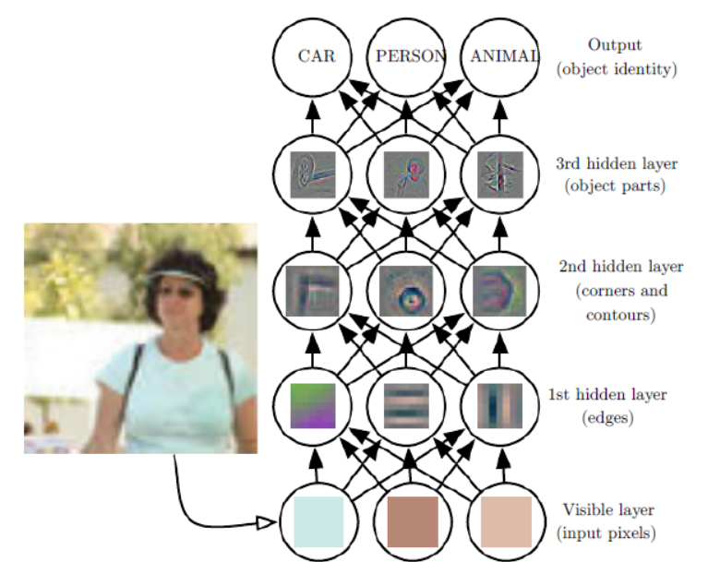

**FIGURE 1**: *The input is presented at the visible layer, so named because it contains visible layer the variables that we are able to observe. Then a series of hidden layers extracts increasingly abstract features from the image. These layers are called “hidden” because their values are not given in the data; instead the model must determine which concepts are useful for explaining the relationships in the observed data. The images here are visualizations of the kind of feature represented by each hidden unit. Given the pixels, the first layer can easily identify edges, by comparing the brightness of neighboring pixels. Given the first hidden layer’s description of the edges, the second hidden layer can easily search for corners and extended contours, which are recognizable as collections of edges. Given the second hidden layer’s description of the image in terms of corners and contours, the third hidden layer can detect entire parts of specific objects, by finding specific collections of contours and corners. Finally, this description of the image in terms of the object parts it contains can be used to recognize the objects present in the image.*

* There are two main ways of measuring the depth of a model. Just as two equivalent computer programs will have different lengths depending on which language the program is written in, the same function may be drawn as a flowchart with different depths depending on which functions we allow to be used as individual steps in the flowchart
* Another approach, used by deep probabilistic models, regards the depth of a model as being not the depth of the computational graph but the depth of the graph describing how concepts are related to each other. For example, an AI system observing an image of a face with one eye in shadow may initially only see one eye. After detecting that a face is present, it can then infer that a second eye is probably present as well. In this case, the graph of concepts only includes two layers—a layer for eyes and a layer for faces—but the graph of computations includes 2n layers if we refine our estimate of each concept given the other n times.
* Because it is not always clear which of these two views—the depth of the computational graph, or the depth of the probabilistic modeling graph—is most relevant, and because different people choose different sets of smallest elements from which to construct their graphs, there is no single correct value for the depth of an architecture, just as there is no single correct value for the length of a computer program. Nor is there a consensus about how much depth a model requires to qualify as “deep.”

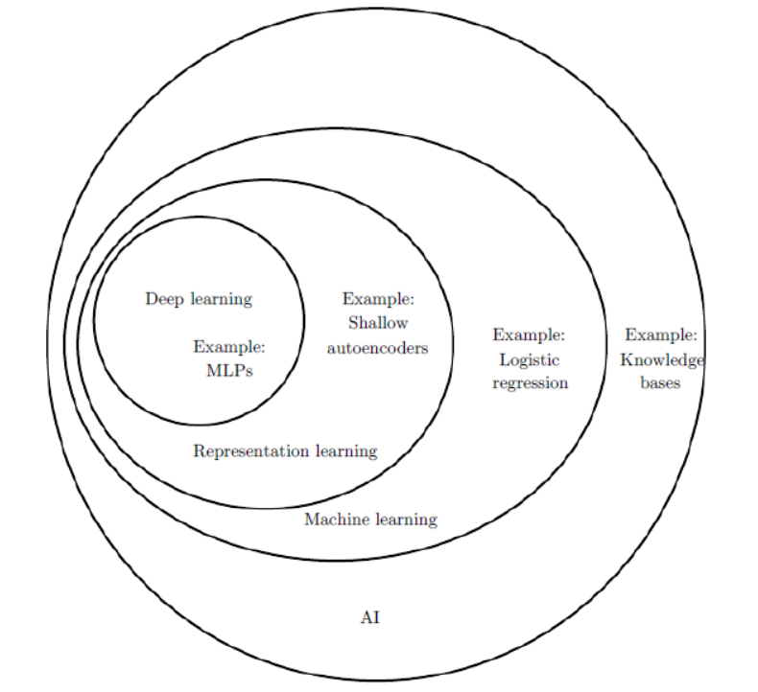

**FIGURE 2**: *A Venn diagram showing how deep learning is a kind of representation learning, which is in turn a kind of machine learning, which is used for many but not all approaches to AI. Each section of the Venn diagram includes an example of an AI technology.*

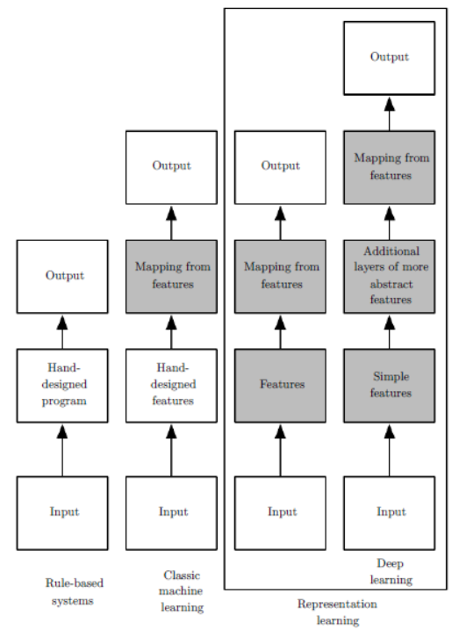

**Figure 3:** *Flowcharts showing how the different parts of an AI system relate to each other within different AI disciplines. Shaded boxes indicate components that are able to learn from data.*

* 1. **Historical Trends in Deep Learning**

We identify a few key trends:

* Deep learning has had a long and rich history, but has gone by many names reflecting different philosophical viewpoints, and has waxed and waned in popularity.
* Deep learning has become more useful as the amount of available training data has increased.
* Deep learning models have grown in size over time as computer hardware and software infrastructure for deep learning has improved.
* Deep learning has solved increasingly complicated applications with increasing accuracy over time.
  + 1. **The Many Names and Changing Fortunes of Neural Networks**
* There have been three waves of development of deep learning:

1. cyberneticsin the 1940s–1960s
2. connectionism in the 1980s–1990s
3. deep learning beginning in 2006
   * + 1. **cybernetics**

* The earliest predecessors of modern deep learning were simple linear models motivated from a neuroscientific perspective. These models were designed to take a set of n input values x1, . . . , xn and associate them with an output y. These models would learn a set of weights w1, . . . , wn and compute their output f(x,w) = x1w1 + · · · + xnwn . This first wave of neural networks research was known as cybernetics*.*
* In the 1950s, the perceptron (Rosenblatt, 1958, 1962) became the first model that could learn the weights defining the categories given examples of inputs from each category.
* The *adaptive linear element* (ADALINE), which dates from about the same time, simply returned the value of f (x) itself to predict a real number (Widrow and Hoff, 1960), and could also learn to predict these numbers from data.
* The training algorithm used to adapt the weights of the ADALINE was a special case of an algorithm called *stochastic gradient descent*. Slightly modified versions of the stochastic gradient descent algorithm remain the dominant training algorithms for deep learning models today.
* Linear models have many limitations. Most famously, they cannot learn the XOR function. Critics who observed these flaws in linear models caused a backlash against biologically inspired learning in general (Minsky and Papert, 1969).This was the first major dip in the popularity of neural networks.
* Neuroscience has given us a reason to hope that a single deep learning algorithm can solve many different tasks. Neuroscientists have found that ferrets can learn to “see” with the auditory processing region of their brain if their brains are rewired to send visual signals to that area (Von Melchner *et al.*, 2000). This suggests that much of the mammalian brain might use a single algorithm to solve most of the different tasks that the brain solves. Before this hypothesis, machine learning research was more fragmented, with different communities of researchers studying natural language processing, vision, motion planning and speech recognition. Today, these application communities are still separate, but it is common for deep learning research groups to study many or even all of these application areas simultaneously.
* The Neocognitron (Fukushima, 1980) introduced a powerful model architecture for processing images that was inspired by the structure of the mammalian visual system and later became the basis for the modern convolutional network (LeCun *et al.*, 1998b). Most neural networks today are based on a model neuron called the *rectified linear* *unit*. The original Cognitron (Fukushima, 1975) introduced a more complicated version that was highly inspired by our knowledge of brain function. The simplified modern version was developed incorporating ideas from many viewpoints, with Nair and Hinton (2010) and Glorot *et al.* (2011a) citing neuroscience as an influence, and Jarrett *et al.* (2009) citing more engineering-oriented influences. While neuroscience is an important source of inspiration, it need not be taken as a rigid guide.
* Also, while neuroscience has successfully inspired several neural network **architectures**, we do not yet know enough about biological learning for neuroscience to offer much guidance for the **learning algorithms** we use to train these architectures.
* One should not view deep learning as an attempt to simulate the brain. Modern deep learning draws inspiration from many fields, especially applied math fundamentals like linear algebra, probability, information theory, and numerical optimization.
* It is worth noting that the effort to understand how the brain works on an algorithmic level is alive and well. This endeavor is primarily known as “computational neuroscience” and is a separate field of study from deep learning. It is common for researchers to move back and forth between both fields.
  + - 1. **Connectionism**
* In the 1980s, the second wave of neural network research emerged in great part, namely a movement called *connectionism parallel distributed* or *processing* (Rumelhart *et al.*, 1986c; McClelland *et al.*, 1995). Connectionism arose in the context of cognitive science. Cognitive science is an interdisciplinary approach to understanding the mind, combining multiple different levels of analysis.
* The central idea in connectionism is that a large number of simple computational units can achieve intelligent behavior when networked together. This insight applies equally to neurons in biological nervous systems and to hidden units in computational models.
* Several key concepts arose during the connectionism movement of the 1980s that remain central to today’s deep learning.
* One of these concepts is that of *distributed representation* (Hinton *et al.*, 1986). This is the idea that each input to a system should be represented by many features, and each feature should be involved in the representation of many possible inputs. For example, suppose we have a vision system that can recognize cars, trucks, and birds and these objects can each be red, green, or blue. One way of representing these inputs would be to have a separate neuron or hidden unit that activates for each of the nine possible combinations: red truck, red car, red bird, green truck, and so on. This requires nine different neurons, and each neuron must independently learn the concept of color and object identity. One way to improve on this situation is to use a distributed representation, with three neurons describing the color and three neurons describing the object identity. This requires only six neurons total instead of nine, and the neuron describing redness is able to learn about redness from images of cars, trucks and birds, not only from images of one specific category of objects.
* Another major accomplishment of the connectionist movement was the successful use of back-propagation to train deep neural networks with internal representations and the popularization of the back-propagation algorithm (Rumelhart *et al.*, 1986a; LeCun, 1987).
* During the 1990s, researchers made important advances in modeling sequences with neural networks. Hochreiter and Schmidhuber (1997) introduced the long short-term memory or LSTM network to resolve some of these difficulties. Today, the LSTM is widely used for many sequence modeling tasks, including many natural language processing tasks at Google.
  + - 1. **Deep Learning**
* The third wave of neural networks research began with a breakthrough in 2006. Geoffrey Hinton showed that a kind of neural network called a deep belief network could be efficiently trained using a strategy called greedy layer-wise pretraining (Hinton *et al.*, 2006). The other CIFAR-affiliated research groups quickly showed that the same strategy could be used to train many other kinds of deep networks (Bengio *et al.*, 2007; Ranzato *et al.*, 2007a) and systematically helped to improve generalization on test examples. This wave of neural networks research popularized the use of the term *deep learning* to emphasize that researchers were now able to train deeper neural networks than had been possible before, and to focus attention on the theoretical importance of depth (Bengio and LeCun, 2007; Delalleau and Bengio, 2011; Pascanu *et al.*, 2014a; Montufar *et al.*, 2014).
* The third wave began with a focus on new unsupervised learning techniques and the ability of deep models to generalize well from small datasets, but today there is more interest in much older supervised learning algorithms and the ability of deep models to leverage large labeled datasets.
  + 1. **Increasing Dataset Sizes**
* One may wonder why deep learning has only recently become recognized as a crucial technology though the first experiments with artificial neural networks were conducted in the 1950s.
* It is true that some skill is required to get good performance from a deep learning algorithm. Fortunately, the amount of skill required reduces as the amount of training data increases.
* The age of “Big Data” has made machine learning much easier because the key burden of statistical estimation—generalizing well to new data after observing only a small amount of data—has been considerably lightened.
* As of 2016, a rough rule of thumb is that a supervised deep learning algorithm will generally achieve acceptable performance with around 5,000 labeled examples per category, and will match or exceed human performance when trained with a dataset containing at least 10 million labeled examples. Working successfully with datasets smaller than this is an important research area, focusing in particular on how we can take advantage of large quantities of unlabeled examples, with unsupervised or semi-supervised learning.
  + 1. **Increasing Dataset Sizes**
* Another key reason that neural networks are wildly successful today after enjoying comparatively little success since the 1980s is that we have the computational resources to run much larger models today.
* Biological neurons are not especially densely connected. In terms of the total number of neurons, neural networks have been astonishingly small until quite recently.
* Larger networks are able to achieve higher accuracy on more complex tasks. This trend looks set to continue for decades. Unless new technologies allow faster scaling, artificial neural networks will not have the same number of neurons as the human brain until at least the 2050s.
* Even today’s networks, which we consider quite large from a computational systems point of view, are smaller than the nervous system of even relatively primitive vertebrate animals like frogs.
  + 1. **Increasing Accuracy, Complexity and Real-World Impact**
* The earliest networks could only recognize two kinds of objects (or in some cases, the absence or presence of a single kind of object), while these modern networks typically recognize at least 1,000 different categories of objects. The largest contest in object recognition is the ImageNet Large-Scale Visual Recognition Challenge (ILSVRC) held each year. A dramatic moment in the meteoric rise of deep learning came when a **convolutional network** won this challenge for the first time and by a wide margin, bringing down the state-of-the-art top-5 error rate from 26.1% to 15.3%. Since then, these competitions are consistently won by deep convolutional nets, and as of 2016, advances in deep learning have brought the latest top-5 error rate in this contest down to 3.6%.
* Goodfellow *et al.* (2014d) showed that neural networks could learn to output an entire sequence of characters transcribed from an image, rather than just identifying a single object. Previously, it was widely believed that this kind of learning required labeling of the individual elements of the sequence (Gülçehre and Bengio, 2013). **Recurrent neural networks**, such as the LSTM sequence model, are now used to model relationships between *sequences* and other *sequences* rather than just fixed inputs. This sequence-to-sequence learning seems to be on the cusp of revolutionizing another application: machine translation (Sutskever *et al.*, 2014; Bahdanau *et al.*, 2015).
* This trend of increasing complexity has been pushed to its logical conclusion with the introduction of **neural Turing machines** (Graves *et al.*, 2014a) that learn to read from memory cells and write arbitrary content to memory cells. Such neural networks can learn simple programs from examples of desired behavior. For example, they can learn to sort lists of numbers given examples of scrambled and sorted sequences. This self-programming technology is in its infancy, but in the future could in principle be applied to nearly any task.
* Another crowning achievement of deep learning is its extension to the domain of **reinforcement learning**. In the context of reinforcement learning, an autonomous agent must learn to perform a task by trial and error, without any guidance from the human operator. DeepMind demonstrated that a reinforcement learning system based on deep learning is capable of learning to play Atari video games, reaching human-level performance on many tasks (Mnih *et al.*, 2015).
* Deep learning has been successfully used to predict how molecules will interact in order to help pharmaceutical companies design new drugs (Dahl *et al.*, 2014), to search for subatomic particles (Baldi *et al.*, 2014), and to automatically parse microscope images used to construct a 3-D map of the human brain (Knowles- Barley *et al.*, 2014).